Pet Clinic Management System

(Microservices)

1. Introduction

1.1 Purpose
This document specifies the functional and non-functional requirements of the Pet Clinic Management System. The system provides secure role-based access to clinic operations such as authentication, pet/owner management, appointments, invoices, and administrative reporting using Spring Boot REST APIs and a microservices architecture.

1.2 Scope
The system is a web application composed of:
- Backend: Spring Boot REST APIs with JWT authentication and role-based authorization.
- Frontend: React application consuming APIs via a single entry point (API Gateway).
- Microservices (Spring Cloud):
  - eureka-server (Service Discovery)
  - api-gateway (Spring Cloud Gateway)
  - main-service (Business logic: Auth, Owners, Pets, Appointments, Invoices, Admin)
- Database: MySQL.
- AOP: Logging aspect for service layer calls.
- Dockerization: Deployment using Docker Compose.
- (Optional) ML Microservice: ml-service for no-show prediction (FastAPI).

1.3 Definitions, Acronyms, Abbreviations
- API: Application Programming Interface
- JWT: JSON Web Token
- RBAC: Role-Based Access Control
- AOP: Aspect-Oriented Programming
- SRS: Software Requirements Specification
- ERD: Entity Relationship Diagram
- Eureka: Service discovery server
- Gateway: API Gateway routing layer

1.4 References
- Spring Boot Documentation
- Spring Security Documentation
- Spring Cloud Gateway Documentation
- Netflix Eureka Documentation
- Docker & Docker Compose Documentation

2. Overall Description

2.1 Product Perspective (Architecture)
The system follows a microservices architecture. The React frontend communicates only with the API Gateway. The gateway routes requests to the main Spring Boot service. Services register with the Eureka server for discovery. MySQL stores the system data.
Insert Architecture Diagram here.

2.2 Product Functions (High-Level)
- User registration, login, logout
- JWT-based authentication and role-based access control
- Owner profile management
- Pet management
- Appointment booking, viewing, canceling, and status updates
- Invoice creation, viewing, and payment
- Admin reporting, user role management, and permission management
- AOP logging for backend service calls
- Containerized deployment using Docker Compose

2.3 User Classes and Characteristics
- ADMIN: Full access to reports, user management, permissions.
- RECEPTIONIST: Manage appointments and invoices; view owners.
- VET: View appointments and update appointment status.
- PET_OWNER: Manage own profile, pets, appointments, and payments.

2.4 Operating Environment
- Java 21, Spring Boot 3.x
- Spring Cloud (Eureka, Gateway)
- MySQL 8.x
- Docker Desktop + Docker Compose
- React + Node.js (Vite)

2.5 Design and Implementation Constraints
- All external traffic must go through the API Gateway.
- Protected endpoints require a valid JWT.
- RBAC rules must be enforced at the API layer.

2.6 Assumptions and Dependencies
- Docker is installed and running.
- Database is reachable via Docker Compose.
- Environment variables for JWT secret and DB credentials are provided.
- (If ML is used) model.pkl and columns.pkl exist inside ml-service.

3. System Requirements

3.1 Functional Requirements
FR-1 Registration: The system shall allow a user to register using name, email, phone, and password.
FR-2 Login: The system shall authenticate users and issue a JWT token stored as an HttpOnly cookie.
FR-3 Logout: The system shall invalidate/revoke the user token on logout.
FR-4 Authentication Guard: The system shall deny access to protected endpoints if the user is not authenticated.
FR-5 Role-Based Authorization: The system shall enforce access control based on user roles (ADMIN, RECEPTIONIST, VET, PET_OWNER).
FR-6 Owner Profile: The system shall allow PET_OWNER to view/update only their own owner profile.
FR-7 Pets Management: The system shall allow PET_OWNER to create/update/delete only their own pets.
FR-8 Book Appointments: The system shall allow PET_OWNER to book appointments only for their own owner profile; RECEPTIONIST may book for any owner.
FR-9 Appointment Access: The system shall allow VET/ADMIN/RECEPTIONIST to view vet appointments; PET_OWNER can view only their appointments.
FR-10 Cancel Appointment: The system shall allow PET_OWNER to cancel only their appointments; ADMIN/RECEPTIONIST may cancel as allowed.
FR-11 Invoice Creation: The system shall allow ADMIN/RECEPTIONIST to create invoices.
FR-12 Invoice Payment: The system shall allow PET_OWNER to pay only invoices belonging to them.
FR-13 Admin Reports: The system shall allow ADMIN to view summary and detailed reports.
FR-14 User Role Update: The system shall allow ADMIN to update other users’ roles and manage permissions.
FR-15 AOP Logging: The system shall log service method calls and exceptions using AOP.
FR-16 Container Deployment: The system shall run using Docker Compose (DB + Eureka + Gateway + Main service).
(Optional)
FR-17 No-Show Prediction: The system shall provide a prediction endpoint for appointment no-show probability.

3.2 Non-Functional Requirements
NFR-1 Security: JWT shall be required for protected endpoints; tokens stored in HttpOnly cookie.
NFR-2 Performance: Typical API responses should be returned within acceptable latency under normal load.
NFR-3 Availability: Services shall be deployable via Docker Compose.
NFR-4 Maintainability: Code shall follow layered architecture (controller/service/repository).
NFR-5 Logging: The system shall log key backend operations via AOP.
NFR-6 Scalability: Services can be scaled independently (gateway/main-service).

4. External Interface Requirements

4.1 API Interfaces (Examples)
Main endpoints (non-exhaustive):
- /api/auth/register, /api/auth/login, /api/auth/logout, /api/auth/me/permissions
- /api/owners/me
- /api/pets/*
- /api/appointments/*
- /api/invoices/*
- /api/admin/*
- (Optional) /api/ml/predict

4.2 User Interface
- Login / Register screens
- Owner/Pet screens for PET_OWNER
- Receptionist dashboard
- Vet dashboard
- Admin dashboard

5. Data Requirements

5.1 Database
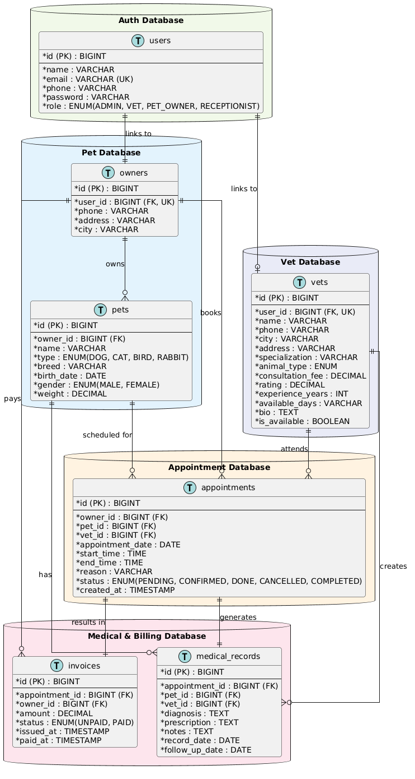
MySQL is used to persist system data. The main entities include users, owners, pets, vets, appointments, invoices, and medical records.

6. System Diagrams
- Use Case Diagram
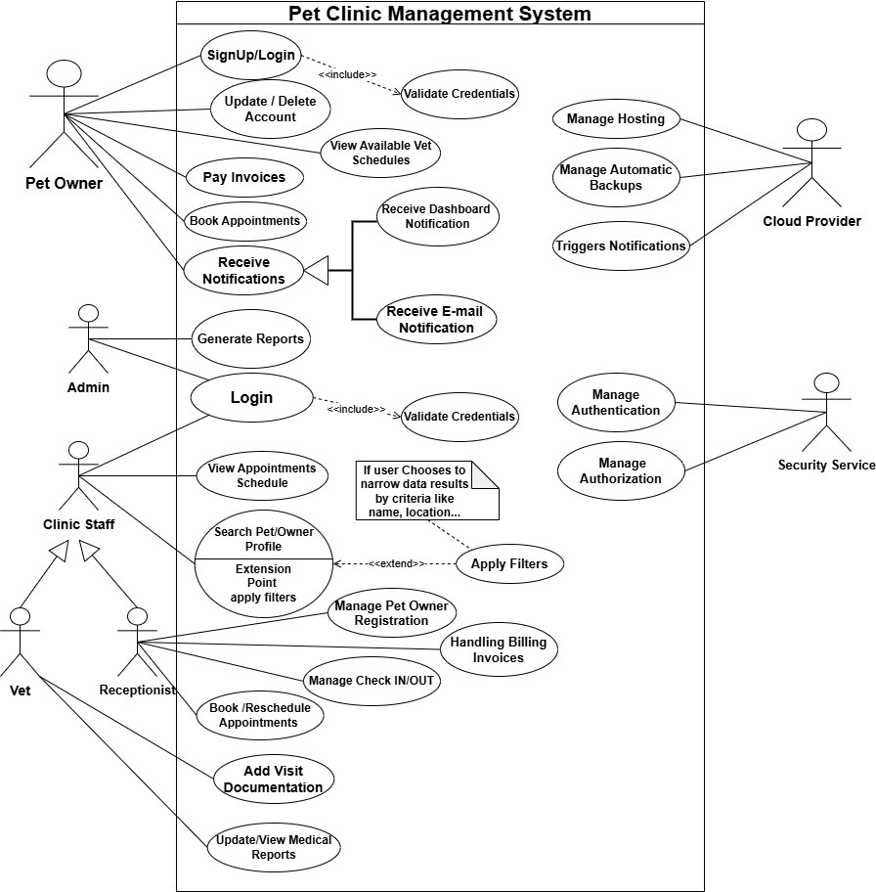

- Class Diagram

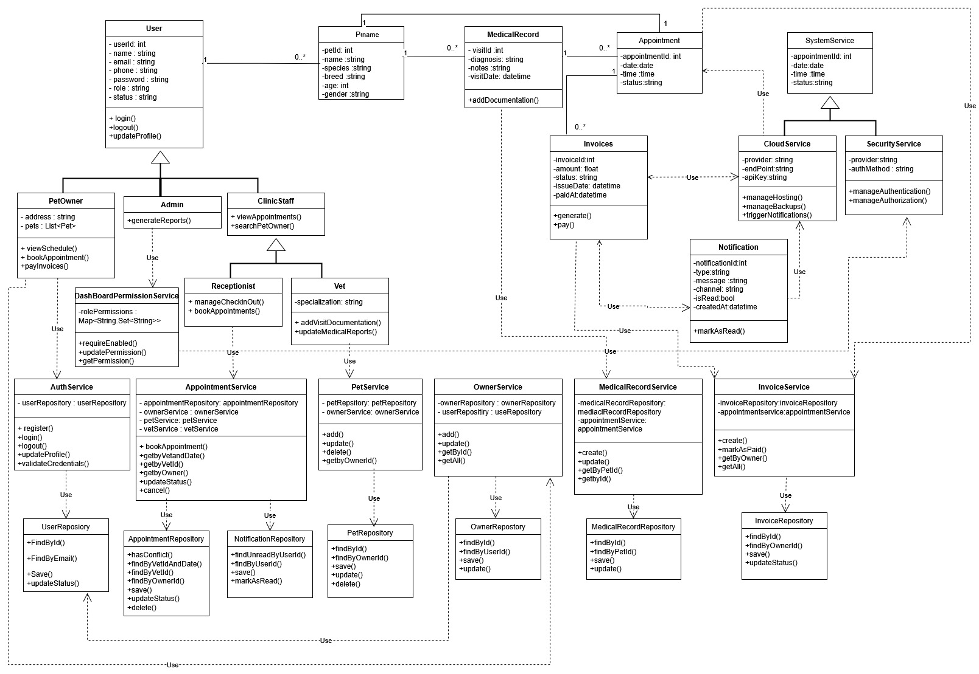

- Sequence Diagrams:
  - Login + JWT
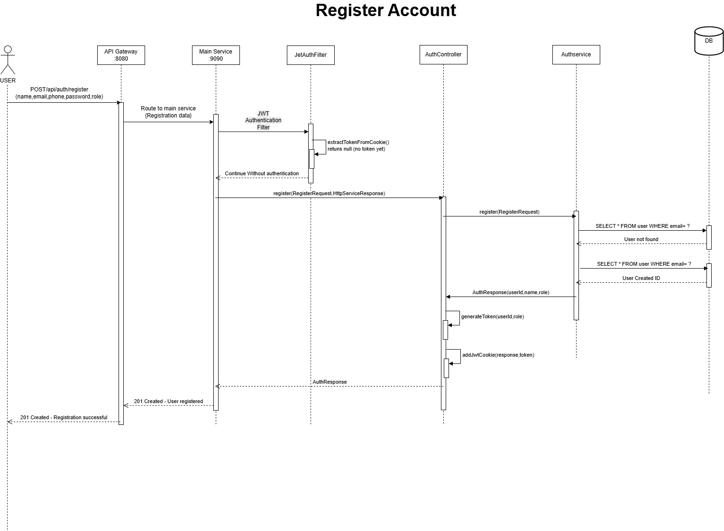

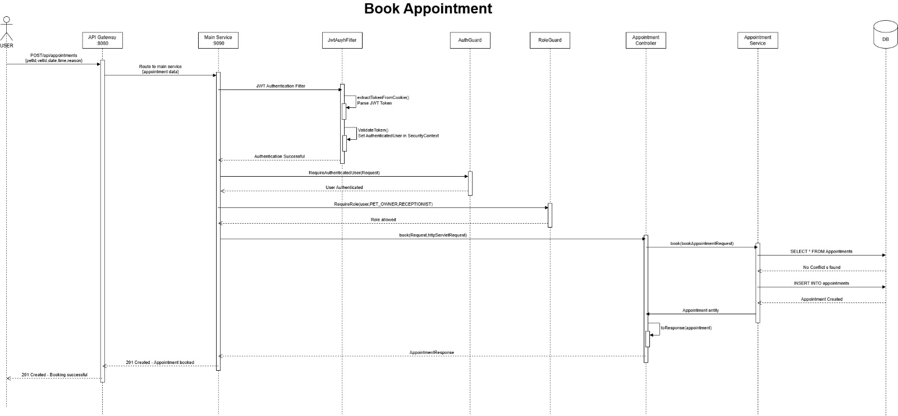
  - Book Appointment

- Activity Diagrams:
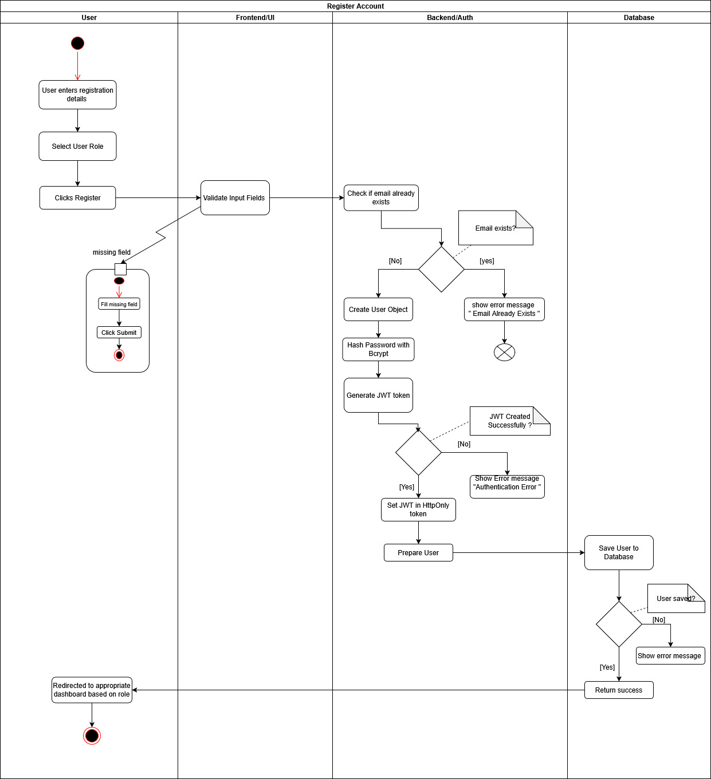
  - Register Account Flow

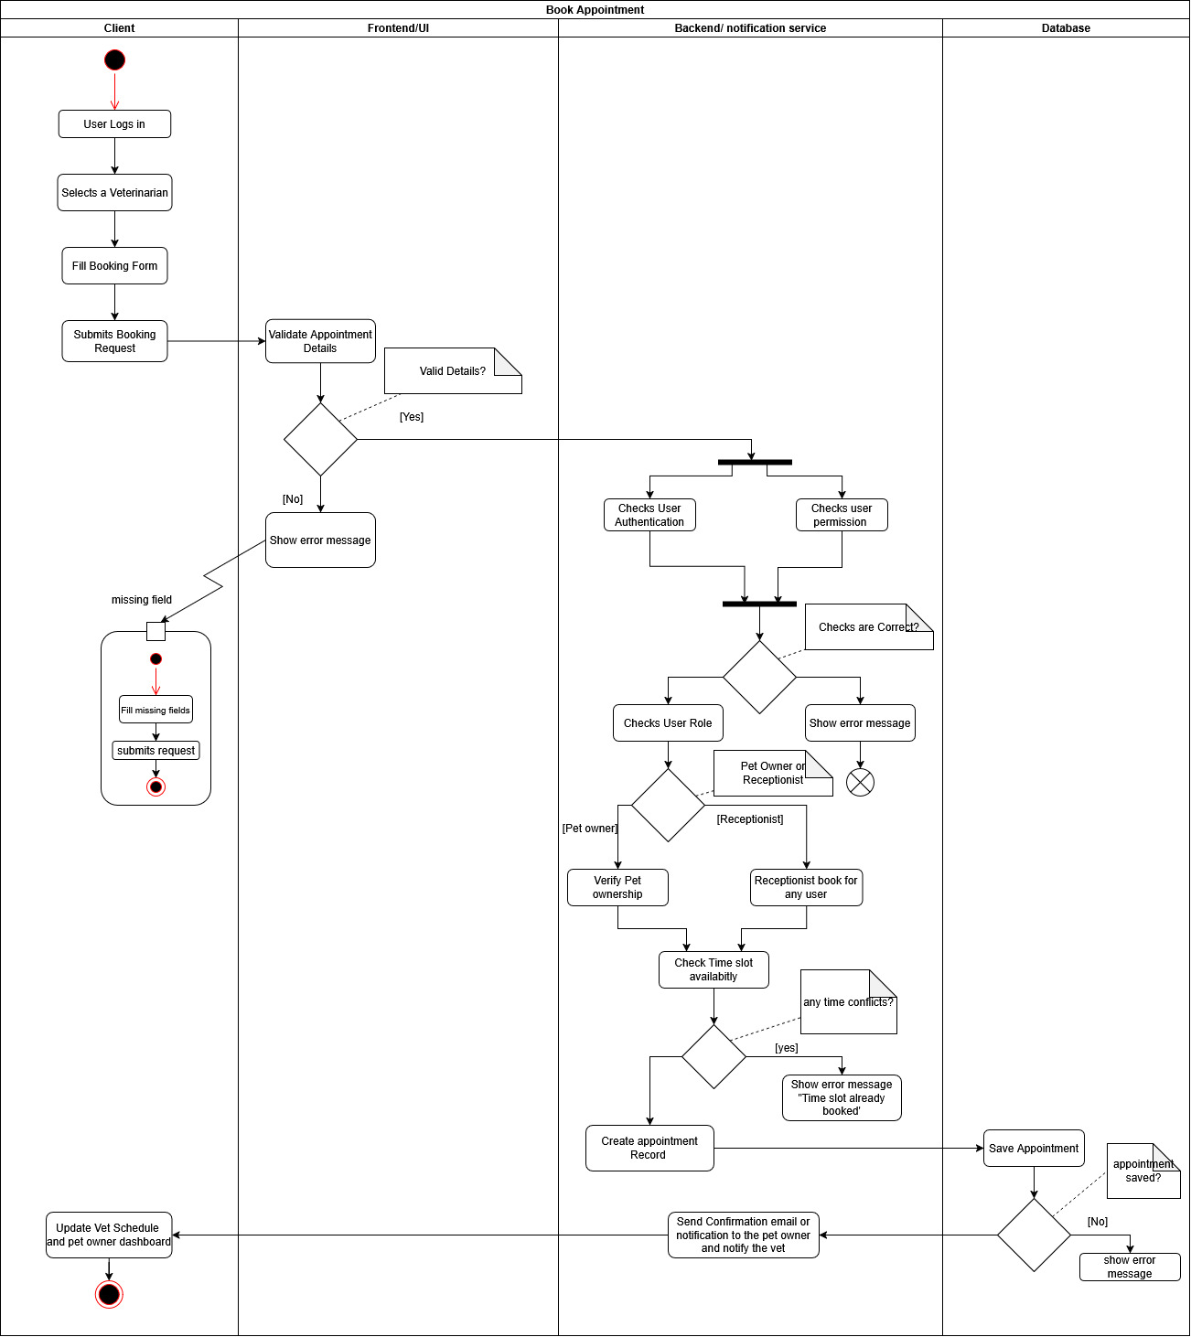
  - Booking Appointment Flow

7. Deployment

7.1 Using Docker Compose
- Run:
  - docker compose up --build
- Services/Ports:
  - Eureka: http://localhost:8761
  - API Gateway: http://localhost:8080
  - Main Service: http://localhost:9090
  - MySQL: localhost:3306
  - (Optional) ML Service: http://localhost:8000 (direct) or via gateway /api/ml/*

7.2 Frontend
- From Frontend/:
  - npm install
  - npm run dev
- Update frontend base API URL to point to the gateway: http://localhost:8080/api

